3GPP TSG-RAN WG1 Meeting #125 R1-2604495
Dalian, China, May 18th – 22th, 2026
Agenda item: 10.8.2
Title: Discussion on OFDM-based Reference Signal Design for 6G ISAC
Source: Shanghai Jiao Tong University，NERC-DTV
Document for: Discussion/Decision

1. Introduction
In RAN#108, the Study Item (SI) on 6G Radio, titled "New SID: Study on 6G Radio," was officially approved [1], marking the beginning of the transition toward next-generation wireless standards. As a cornerstone of the 6G vision defined in the ITU-R IMT-2030 framework, Integrated Sensing and Communication (ISAC) has been recognized as one of the six key usage scenarios. To realize this vision, the physical layer design must evolve from "communication-only" to a harmonized framework capable of supporting high-precision sensing alongside robust data transmission.
According to agenda item 10.8.2 in [2], RAN1 is tasked with investigating technical solutions for the co-design of sensing and communication functionalities. This specifically includes the study of dedicated reference signals (RS) that can be embedded into Orthogonal Frequency Division Multiplexing (OFDM) frames. While CP-OFDM remains the baseline for 5G-Advanced and 6G, its current structure is optimized primarily for communication multipath channels and does not inherently meet the stringent requirements of high-performance sensing. Key challenges that must be addressed within the scope of this meeting include:
- Performance and Resource Trade-offs: The density and pattern of RS placement create a fundamental tension between sensing's unambiguous delay-Doppler detection range and communication's throughput.
- Velocity Ambiguity and Ghost Targets in Multi-Target Tracking: Sparse time-domain RS introduces velocity ambiguity peaks. Unfolding these peaks with CRT requires a large number of CPIs to suppress ghost targets, causing severe latency issues in multi-target tracking.
- Inter-Symbol Interference (ISI) in Long-Range Scenarios: In use cases such as Unmanned Aerial Vehicles (UAVs) detection, target echoes often exceed the standard Cyclic Prefix (CP) duration, leading to ISI and the destruction of subcarrier orthogonality.
- Inter-Carrier Interference (ICI) in High-Mobility Scenarios: High speed targets introduce severe Doppler effects across both Sub 6GHz and mmWave bands, leading to ICI that degrades sensing Signal-to-Interference-plus-Noise Ratio (SINR).
To address these challenges, we analyze the ambiguity function of uniform alternative scattered RS patterns, introduce a multi-CPI RS configuration combined with physical range-rate verification to unfold velocity ambiguity, propose structural enhancements to mitigate ISI for long-range detection and evaluate the performance impact of Doppler-induced ICI. The proposed solutions aim to achieve a harmonized design that supports both high-performance sensing and efficient data transmission within a unified framework.

2. Ambiguity function analysis
In OFDM based ISAC systems, the insertion structure and spacing of reference signals in the time frequency domain directly impact the sensing performance, specifically shaping the ambiguity function. Different reference signal arrangements yield distinct ambiguity peak characteristics in the Range Doppler map. Mathematically, the sensing boundary is defined by the maximum unambiguous detection range and the maximum unambiguous velocity. These theoretical limits are inversely proportional to the reference signal insertion intervals in the frequency and time domains respectively, and can be formulated as follows:
$$R_{max}=\frac{c}{2∆fN_{f}} ,$$
$$v_{max}=\frac{c}{4f_{c}T_{0}N_{t}} ,$$
where $c$ denotes the speed of light, $∆f$ represents the subcarrier spacing, and $T_{0}$ is the symbol duration. The variables $N_{f}$ and $N_{t}$ indicate the spacing intervals of the reference signals across the frequency domain subcarriers and the time domain symbols respectively. These fundamental equations reveal a physical constraint where the increase in the reference signal spacing will directly shrink the corresponding unambiguous detection boundaries. To properly evaluate these impacts, specific system parameters are established utilizing a 120 kHz subcarrier spacing which corresponds to an 8.9 microsecond OFDM symbol duration and a 28 GHz center frequency.
Under these parameters, a conventional uniform grid pattern generates standard and periodic ambiguity peaks forming a rectangular layout. To clearly understand this mechanism, it is essential to analyze how RS placement across different dimensions independently triggers range and velocity ambiguity.
First, as illustrated in Figure 1(a), when reference signals are placed on all subcarriers but at equal intervals across the symbol dimension, multiple repeating peaks are generated in the velocity dimension during the sensing process, as shown in Figure 2(a). The horizontal distance between these adjacent peaks directly determines the maximum unambiguous velocity.
Conversely, as illustrated in Figure 1(b), if reference signals are placed on all symbols but at equal intervals across the subcarriers, the continuous temporal coverage ensures a high maximum unambiguous velocity. However, the frequency gaps cause range ambiguity peaks to occur, as shown in Figure 2(b), resulting in a severely reduced maximum unambiguous detection range.
As shown in Figure 1(c), when the uniform scattered pilots are applied, meaning reference signals are spaced at sparse equal intervals in both the time and frequency dimensions, the resulting Range-Doppler map exhibits a rectangular layout of ambiguity peaks in both range and velocity. While this regular structure is straightforward for channel estimation, it strictly bounds both the maximum unambiguous detection range and velocity simultaneously based on the pilot spacing.
To address the ambiguous problem and provide flexible configurations with limited resource overhead, a scattered RS pattern (e.g., uniform alternative scattered pilots across subcarriers and symbols) can be considered for 6G ISAC, as shown in Fig. 1(d). This specific RS arrangement offers significant advantage for sensing operations.
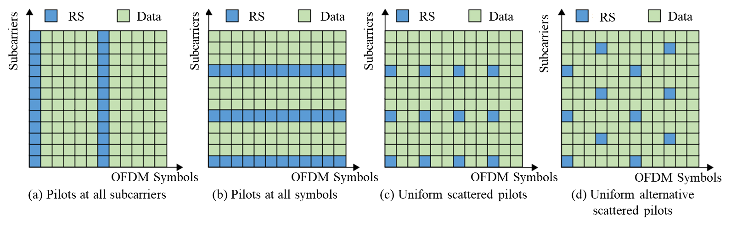
Figure 1: The pilot structures in OFDM frame
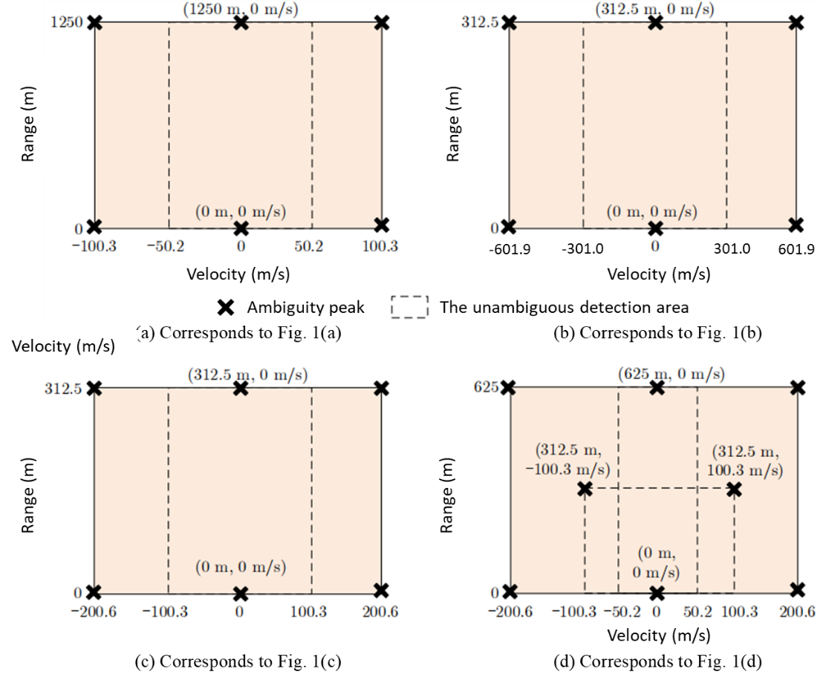
Figure 2: The ambiguous peak and unambiguous detection area for different pilot structures
It provides flexible optional unambiguous detection area. Unlike a conventional uniform grid that generates a standard rectangular unambiguous region in the Range Doppler map, the alternating structure introduces a geometric shift in the ambiguity peaks. This shift reshapes the unambiguous area into a parallelogram, which naturally offers two optional maximum unambiguous detection regions, as illustrated in Fig. 2(d). Depending on the specific application scenario, the system can adaptively configure the most suitable detection boundaries to prioritize either an extended unambiguous range or a higher maximum unambiguous velocity.
Generally, a higher RS density expands the unambiguous delay-Doppler region. However, this inherently leads to greater resource overhead, which limits the communication rate. Consequently, two critical trade-offs emerge in ISAC waveform and resource design:
- Trade-off between Sensing and Communication: Increasing the RS density effectively expands the unambiguous delay-Doppler region and enhances the sensing processing gain. However, this densely populated RS pattern inherently consumes time-frequency resources that would otherwise be allocated for data transmission, leading to a fundamental trade-off between sensing coverage and communication throughput. Therefore, the RS pattern and resource allocation need to be jointly optimized to balance the dual functions within a limited resource budget.
- Trade-off between Unambiguous Range and Unambiguous Velocity: Even under a fixed RS overhead, the specific geometric arrangement of pilots introduces a trade-off between the unambiguous range and velocity. Depending on the pattern design experiment, it can be observed in Fig. 2 that expand the maximum unambiguous range often inherently sacrifices the maximum unambiguous velocity capability.
Observation 1: The RS pattern design in ISAC introduces fundamental trade-offs between sensing and communication capacity, as well as between unambiguous range and unambiguous velocity.
Observation 2: The uniform alternative scattered RS pattern provides flexible optional unambiguous detection area and enables the resolution of ambiguity peaks by utilizing physical velocity estimation across multiple CPIs.
Proposal 1: RAN1 to study reference signal pattern designs for 6G ISAC systems to optimally balance sensing and communication resources, and to address the fundamental compromise between maximum unambiguous range and unambiguous velocity.
Proposal 2: RAN1 to evaluate the uniform alternative scattered reference signal pattern for 6G ISAC systems, specifically focusing on its ability to support flexible unambiguous detection boundaries and mitigate delay Doppler ambiguity through multiple CPIs physical velocity tracking.

3. Reference Signal Design for Velocity Sensing
As discussed in Section 2, achieving a high maximum unambiguous velocity traditionally requires a dense RS configuration in the time domain, which severely restricts communication throughput. To resolve velocity ambiguity without increasing the RS overhead, a multi-CPI RS configuration combined with physical range-rate verification can be utilized.
3.1 CRT-based Velocity Unfolding
By configuring different RS symbol spacing intervals $N_{t}$ across adjacent CPIs, the system generates distinct maximum unambiguous velocities $V_{ul}$ for each CPI. According to the Chinese Remainder Theorem (CRT), the true target velocity $V$ can be mathematically resolved by finding the congruence across the aliased velocity measurements $V_{al}$ from $L$ different CPIs:
$$V≡V_{al} mod V_{ul }, l=1,2,…,L$$
This mechanism effectively extends the unambiguous velocity boundary. It is important to note that this velocity disambiguation framework is a universal solution. It is applicable to both the conventional uniform scattered pilots in Fig. 1(c) and the alternative scattered pilots with frequency offsets in Fig. 1(d). But the alternative scattered pilots in Fig. 1(d) provides additional flexibility in shaping the unambiguous detection boundaries. Under this specific arrangement, the detection range reaches the maximum unambiguous boundary of the system while the coupled velocity ambiguities are resolved, thereby extending the maximum unambiguous range and velocity without increasing pilot overhead.
While the CRT method is effective for a single target, it inevitably generates "ghost targets" in multi-target scenarios (e.g., UAV swarms) due to incorrect pairings of aliased velocity peaks. Traditional CRT approaches require $N+1$ CPIs to reliably resolve $N$ targets, which causes unacceptable processing delays for highly mobile targets and lacks robustness.
For instance, assuming two targets need to be detected (e.g., at 27 m/s and 40 m/s), the RS symbol spacings across three consecutive CPIs can be configured as $N_{t}=7$, $N_{t}=10$, and $N_{t}=11$, as illustrated in Fig. 3. These coprime spacings correspond to maximum unambiguous velocities of $V_{u1 }=43m/s$, $V_{u2 }=30m/s$, and $V_{u3 }=27m/s$, respectively. As demonstrated in the CRT-based multi-target velocity detection in Fig. 4, if only the first two CPIs are utilized, the ambiguous peaks of the true estimated velocities coincide perfectly, but a ghost target is incorrectly generated at 70 m/s. Eliminating this specific ghost target fundamentally relies on the additional RS configuration provided by the third CPI.
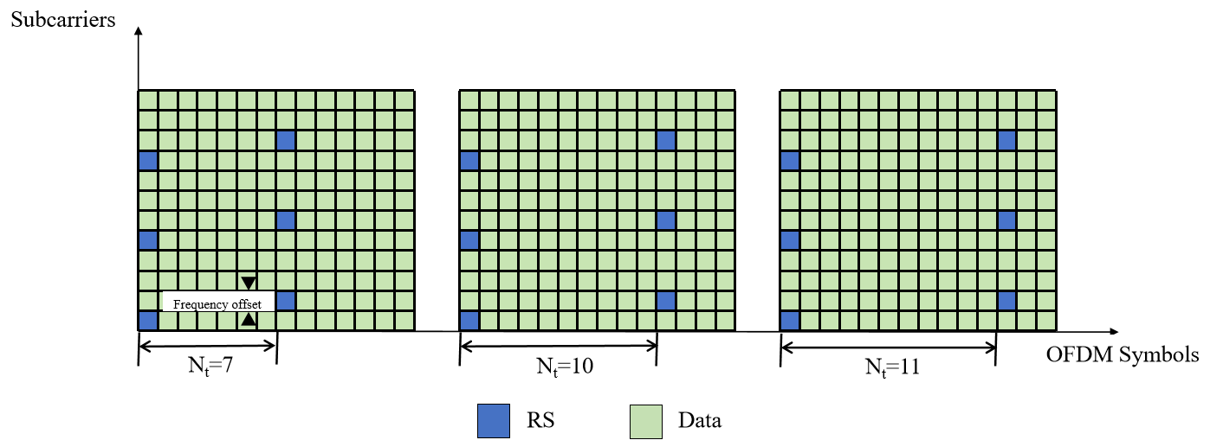
Figure 3: Illustration of RS design based on CRT
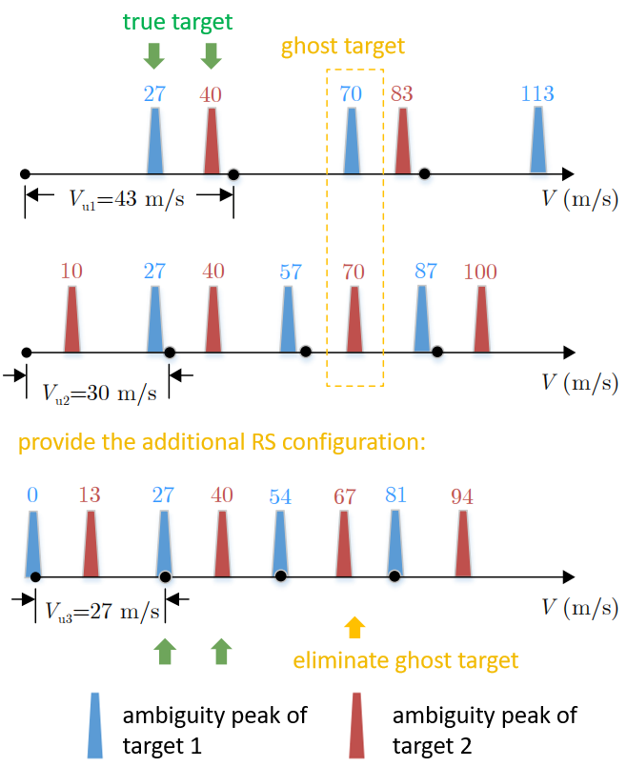
Figure 4: Illustration of resolving velocity ambiguity in multi-target scenarios based on CRT
3.2 Ghost Target Elimination via Physical Range-Rate
To efficiently eliminate these ghost targets, a physical range-rate verification mechanism is introduced. Since the system estimates both delay and Doppler, the true target velocity must strictly align with the physical distance change rate across CPIs. The procedure is as follows:
The system computes the mathematical velocities using the CRT method across two adjacent CPIs. The system simultaneously extracts the range estimates ($R_{1}^{k}$ and $R_{2}^{k}$) from the same two CPIs separated by time $∆t$ to calculate the physical range-rate ${\hat{V}}^{k}$:
$${\hat{V}}^{k}=\frac{R_{2}^{k}-R_{1}^{k}}{∆t}$$
The CRT-derived velocity $V^{k}$ is compared against the physical range-rate ${\hat{V}}^{k}$. If the difference exceeds the minimum unambiguous velocity bounds, it is identified as a ghost target and discarded.
By leveraging this coupled delay-Doppler physical relationship, the system requires only two CPIs with sparsely distributed RS to reliably resolve multi-target velocity ambiguity. This structural design drastically reduces the time-domain RS overhead while guaranteeing robust high-speed sensing performance.
Observation 3: Traditional CRT-based velocity disambiguation suffers from "ghost targets" and N+1 CPIs in multi-target scenarios. Integrating physical range-rate verification enables robust velocity unfolding and ghost target elimination using only two CPIs, significantly reducing RS overhead and sensing delay.
Proposal 3: RAN1 to study multi-CPI reference signal configurations combined with physical range-rate verification to effectively eliminate ghost targets and resolve velocity ambiguity for high-speed multi-target 6G ISAC scenarios.

4. Reference Signal Design for Long-Range Sensing
While OFDM is the baseline waveform for 5G NR and 6G, its current frame structure is optimized for communication multipath channels rather than long-range sensing. For sensing targets at large distances, such as UAVs, the round-trip time (RTT) often exceeds the standard CP duration, leading to ISI. This section discusses RS design strategies to mitigate ISI in long-range ISAC scenarios.
4.1 Analysis of ISI Problem in Long-Range Sensing
In standard 5G NR, the CP duration fundamentally constrains the ISI-free sensing range. At a sub-carrier spacing (SCS) of 60 kHz, the normal CP duration is approximately 1.17 $μs$, which limits the sensing range to about 175 meters. Even by employing the extended CP (ECP) with a duration of 4.17 $μs$, the ISI-free sensing range only extends to approximately 625 meters. This limitation is further exacerbated in millimeter-wave (mmWave) bands; when a 120 kHz SCS is utilized, the even shorter CP duration leads to a more restricted sensing distance. However, practical UAV detection scenarios typically require detection up to 1000 meters, which corresponds to a RTT of 6.67 $μs$, far exceeding the capabilities of standard CP configurations.
As illustrated in Fig.5, when the echo delay $τ$ exceeds $T_{CP}$, the FFT window at the receiver captures energy from both the current symbol and the tail of the preceding symbol, resulting in:
- Orthogonality Destruction: Subcarrier orthogonality is lost, causing significant ICI.
- Structural Interference Floor: Unlike thermal noise, ISI energy scales with transmit power. Consequently, increasing power would significantly elevating the noise floor in the Range-Doppler Map.
- Target Masking: Weak echoes from distant targets are submerged under the elevated interference floor of stronger, closer targets or preceding data symbols.

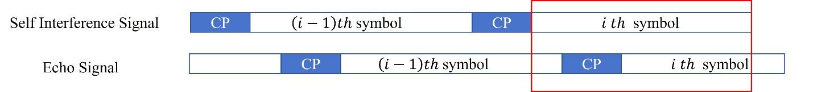
Figure 5: The timeline for received OFDM symbols
Observation 4: Standard CP lengths in existing OFDM frameworks are insufficient for long-range sensing. Pure power-based approaches or conventional extended CP fails to mitigate ISI, necessitating structural reference signal enhancements.
4.2 Periodic RS Design via Frequency-Domain Sparsity
Although exceeding ECP specifications can directly accommodate the increased round-trip delay, it would consume excessive resources, leading to a severe penalty in spectral efficiency. To overcome this, we leverage the fact that ISI protection essentially requires time-domain periodicity. Specifically, by logically partitioning an OFDM symbol into $N$ repeated segments, the equivalent CP length $L_{eq}$ can be significantly enhanced without physical overhead:
$$L_{eq}=\frac{N-1}{N}(T-T_{CP})+T_{CP}$$
where $T$ is the total symbol duration and $T_{CP}$ represents the original CP length.
While this logical padding structure achieves the desired range extension (e.g., to 1400m for $N=2$ at 60 kHz SCS), its physical layer implementation is more efficiently realized in the frequency domain through alternating non-zero-power RS (NZP-RS) and zero-power RS (ZP-RS) design. The method in [3] exploits the duality between frequency-domain sparsity and time-domain periodicity to create the necessary protection zone for echoes without the overhead of physical CP expansion. The detailed implementation consists of the following steps:
- Periodic Waveform Construction
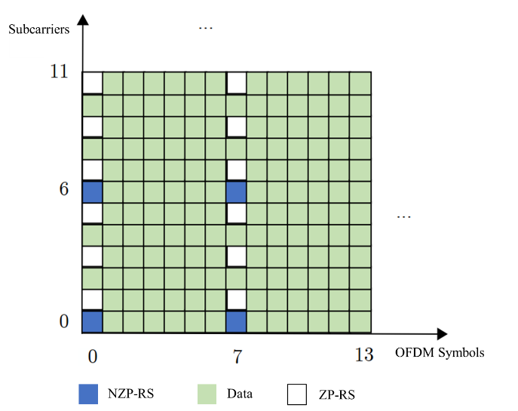
Figure 6: Illustration of alternating NZP-RS and ZP-RS design
By deploying NZP-RS and ZP-RS alternately on subcarriers (e.g., NZP-RS on even subcarriers $k=2m$ and ZP-RS on odd subcarriers $k=2m+1$) as illustrated in Fig.6, the time-domain signal $x_{e}[n]$ naturally exhibits a periodicity of $T_{d}/2$, effectively creating two identical segments within one OFDM symbol duration. Based on the Inverse Discrete Fourier Transform (IDFT) properties, the generated time-domain signal $x_{e}[m]$ is derived as:
$$x_{e}[n]=\frac{1}{N_{c}}\sum_{n=0}^{N_{c}-1}{X_{e}[n]e^{j\frac{2πnm}{N_{c}}}}=\frac{1}{2}x[m]g\left[\frac{m}{N_{c}/2}\right]+\frac{1}{2}x\left[m-N_{c}/2\right]g\left[\frac{m-N_{c}/2}{N_{c}/2}\right]$$
where $N_{c}$ is the total number of subcarriers, $X_{e}[n]$ denotes the interleaved frequency-domain symbols, and x[m] represents the $N_{c}/2$-point IDFT of the NZP-RS sequence, $m=0,1,⋯N_{c}-1$. $g\left[∙\right]$ represents the discrete impulse response function.
- ISI-Free Sampling Mechanism
The receiver discards the first half of the symbol contaminated by ISI and performs FFT exclusively on the second-half samples. Due to the constructed periodicity, these samples maintain the integrity of the original frequency-domain RS information, which can fully reconstruct the sensing channel without the spectral leakage or noise floor elevation. When the echo delay $τ$ satisfies $T_{CP}<τ≤T_{CP}+T_{d}/2$, the second half of the current symbol remains entirely ISI-free, providing an additional 1250m to the effective sensing range for a 60 kHz SCS system.
Proposal 4: The alternating NZP-RS and ZP-RS frequency-domain pattern design combined with receiver half-symbol sampling mechanism should be considered for long-range sensing. This allows the receiver to avoid ISI with reduced spectral overhead.

5. Impact of Inter-Carrier Interference (ICI) in High-Mobility Sensing
While CP-OFDM is the baseline waveform for 5G NR and serves well for communications, its orthogonality is highly sensitive to Doppler shifts. In 6G ISAC networks, detecting high-speed targets at mmWave bands introduces severe Doppler effects, which strictly degrade the sensing performance due to ICI.
To illustrate the importance of this issue, we can evaluate the normalized Doppler shift based on typical mmWave 6G physical layer parameters. Assuming a carrier frequency of 26 GHz and a subcarrier spacing of 120 kHz, we evaluate a high-mobility target flying at 500 km/h (138.9 m/s). For a monostatic sensing scenario, the maximum round-trip Doppler shift $f_{d}$ is calculated as
$$f_{d}=\frac{2v}{c}f_{c}$$
where $v$ is the target velocity and $c$ is the speed of light. Substituting the values yields a Doppler shift of approximately 24.08 kHz.
Consequently, the normalized Doppler shift $ϵ$ relative to the subcarrier spacing is
$$ϵ=\frac{f_{d}}{∆f}=\frac{24.08}{120}≈0.2$$
A normalized Doppler shift exceeding 0.1 significantly destroys the orthogonality between OFDM subcarriers. In this scenario, reaching the normalized Doppler shift of 0.2 leads to severe ICI energy leakage across adjacent subcarriers. This heavy ICI causes phase rotations, elevates the noise floor, and drastically degrades the SINR of the sensing echoes. As a result, the peak detection in the Range-Doppler map is blurred, making precise velocity estimation and weak target detection unreliable. Given the 6G requirements to support extreme mobility, the ICI problem inherent in the OFDM waveform will be magnified, acting as a major problem for high-accuracy ISAC operations.
While mmWave bands generate massive absolute Doppler shifts, Sub 6GHz bands are even more vulnerable due to their narrow subcarrier spacings. To illustrate the severity of this issue across different frequency bands, we can evaluate the maximum target velocity required to reach a normalized Doppler shift of 10%. The formula of maximum detectable velocity as follows:
$$v_{max}=\frac{0.1×∆f∙c}{2f_{c}}$$
Based on the formula above, Table 1 demonstrates the critical target velocities that trigger severe Inter Carrier Interference under typical Sub 6GHz and mmWave physical layer parameters. As shown in Table 1, operating at 6 GHz with a 15 kHz subcarrier spacing triggers severe Inter Carrier Interference at only 37.5m/s, a velocity easily exceeded by modern high speed trains. Similarly, mmWave operations at 26 GHz with a 120 kHz subcarrier spacing face degradation at 69.23 m/s. This demonstrates that Sub 6GHz systems are actually more susceptible to ICI in high mobility scenarios.
Table 1: Target maximum velocity under various carrier frequencies and subcarrier spacings
Band | Subcarricr spacing(kHz) | the normalized Doppler shift | Maximum velocity(m/s)
6GHz | 15 | 0.1 | 37.5
 | 30 | 0.1 | 75
 | 60 | 0.1 | 150
26GHz | 120 | 0.1 | 69.23
 | 240 | 0.1 | 138.46
Observation 5: High mobility targets generate severe ICI that destroys OFDM subcarrier orthogonality across both Sub 6GHz and mmWave frequencies, with Sub 6GHz bands being highly vulnerable at high speed velocity due to their narrow subcarrier spacings.
Proposal 5: RAN1 to study the performance degradation caused by ICI in OFDM-based 6G ISAC systems under high-mobility scenarios, and to discuss potential enhancements, processing techniques, or complementary waveform designs to mitigate this issue in future meetings.

6. Conclusions
In this contribution, we presented our views on waveform candidates for 6G sensing. Our proposals and observations are listed below.
Observation 1: The RS pattern design in ISAC introduces fundamental trade-offs between sensing and communication capacity, as well as between unambiguous range and unambiguous velocity.
Observation 2: The uniform alternative scattered RS pattern provides flexible optional unambiguous detection ranges and enables the resolution of ambiguity peaks by utilizing physical velocity estimation across multiple CPIs.
Observation 3: Traditional CRT-based velocity disambiguation suffers from "ghost targets" and N+1 CPIs in multi-target scenarios. Integrating physical range-rate verification enables robust velocity unfolding and ghost target elimination using only two CPIs, significantly reducing RS overhead and sensing delay.
Observation 4: Standard CP lengths in existing OFDM frameworks are insufficient for long-range sensing. Pure power-based approaches fail to mitigate ISI, necessitating structural reference signal enhancements.
Observation 5: High mobility targets generate severe ICI that destroys OFDM subcarrier orthogonality across both Sub 6GHz and mmWave frequencies, with Sub 6GHz bands being highly vulnerable at high speed velocity due to their narrow subcarrier spacings.
Proposal 1: RAN1 to study reference signal pattern designs for 6G ISAC systems to optimally balance sensing and communication resources, and to address the fundamental compromise between maximum unambiguous range and unambiguous velocity.
Proposal 2: RAN1 to evaluate the uniform alternative scattered reference signal pattern for 6G ISAC systems, specifically focusing on its ability to support flexible unambiguous detection boundaries and mitigate delay Doppler ambiguity through multiple CPIs physical velocity tracking.
Proposal 3: RAN1 to study multi-CPI reference signal configurations combined with physical range-rate verification to effectively eliminate ghost targets and resolve velocity ambiguity for high-speed multi-target 6G ISAC scenarios.
Proposal 4: The alternating NZP-RS and ZP-RS frequency-domain pattern design combined with receiver half-symbol sampling mechanism should be considered for long-range sensing. This allows the receiver to avoid ISI with reduced spectral overhead.
Proposal 5: RAN1 to study the performance degradation caused by ICI in OFDM-based 6G ISAC systems under high-mobility scenarios, and to discuss potential enhancements, processing techniques, or complementary waveform designs to mitigate this issue in future meetings.

7. References
[1] RP-251881, “New SID: Study on 6G Radio,” NTT DOCOMO (Moderator).
[2] R1-2603480, “Draft Agenda,” Chair (3GPP TSG-RAN WG1 Meeting #125, May 2026).
[3] A. Tang, Q. Zhao, X. Wang and W. Qu, "ISI-Resistant Reference Signal Design and Processing for OFDM Integrated Communications and Long-Range Radar Sensing," in IEEE Communications Letters, vol. 28, no. 6, pp. 1322-1326, June 2024.

